**FLEETFUEL - THE ONLINE FUEL DELIVERY WEB APPLICATION**

**Design Document**

**Version 1.0**



**Group Id: F2302D2C89**

**Supervisor Name:** Hafiz Muhammad Azeem Sarwar

**Revision History**

|  |  |  |  |
| --- | --- | --- | --- |
| **Date (dd/mm/yyyy)** | **Version** | **Description** | **Tested By** |
| **9/01/24** | **1.0** |  | BC190402933 SUGHRA BIBI |
|  |  |  |  |
|  |  |  |  |
|  |  |  |  |

**Table of Contents**

1. Introduction of Design Document
2. Entity Relationship Diagram (ERD)
3. Sequence Diagrams
4. Architecture Design Diagram
5. Class Diagram
6. Database Design
7. Interface Design
8. Test Cases

1. Introduction of Design Document

The Design Document maps the requirements into architecture-independent of how these requirements will be accomplished. The architecture defines the components, their interfaces, and behaviors. In the Design Phase, we transform the requirements gathered during the Analysis Phase into a Design Document that accurately describes the design of the system.

The purpose of the Design Phase is to transform the requirements into complete and detailed system design specifications once the design is approved the Design Document will serve as input to the Development Phase. Tools and techniques used in this phase are listed below:

* ER Diagram
* Sequence Diagram
* Architecture Design Diagram
* Class Diagram
* Database Design
* Interface Design
* Test Cases

1. 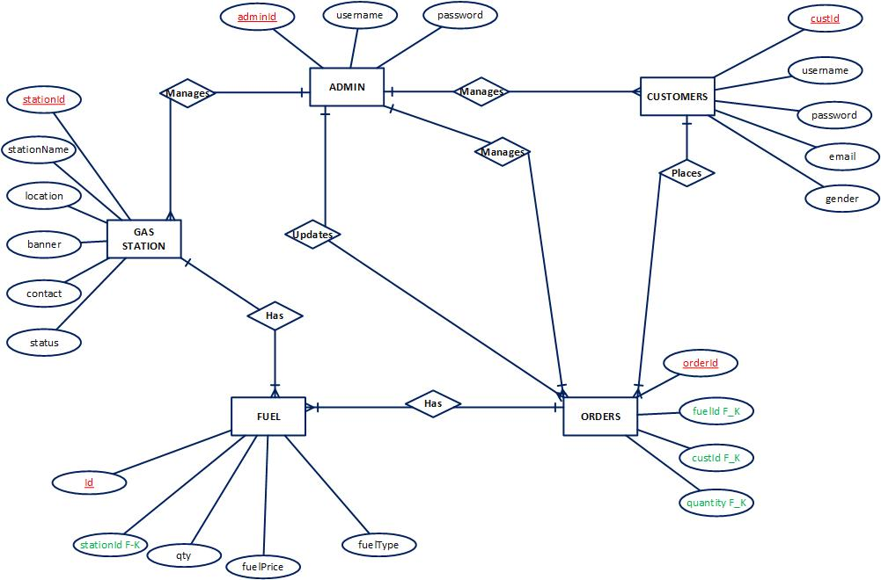Entity Relationship Diagram (ERD)
2. Sequence Diagrams

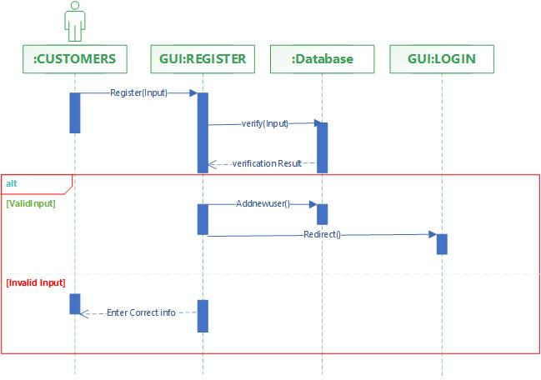Registration:

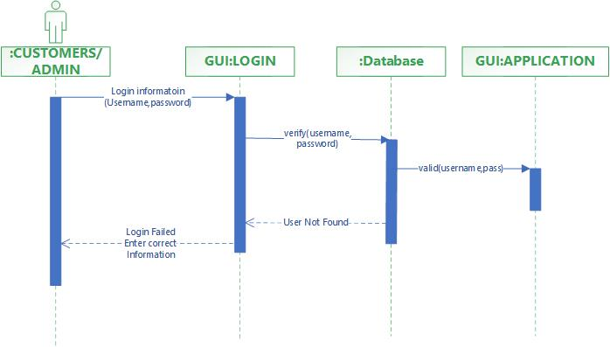Login Panel:

Add Gas Station:

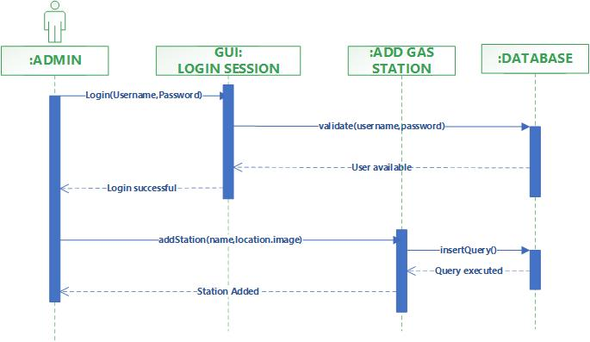

Manage Gas Station

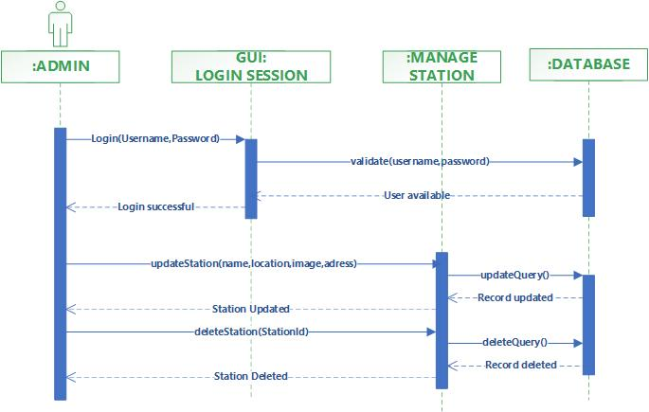

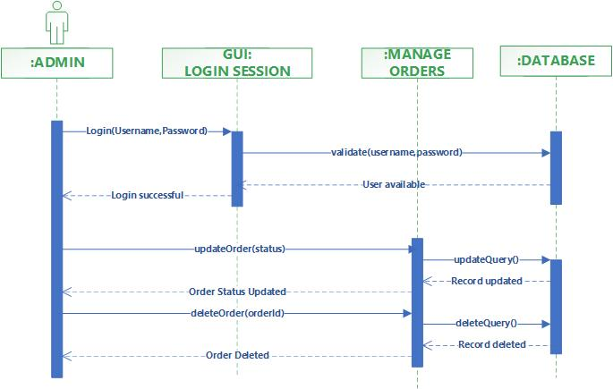Manage Orders

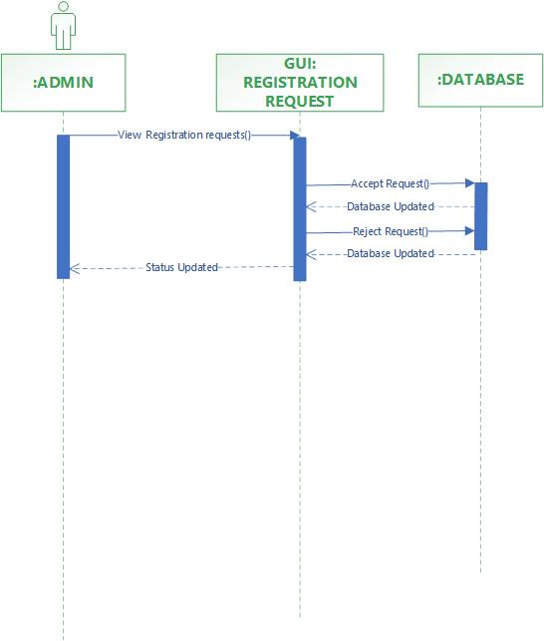Manage Requests:-

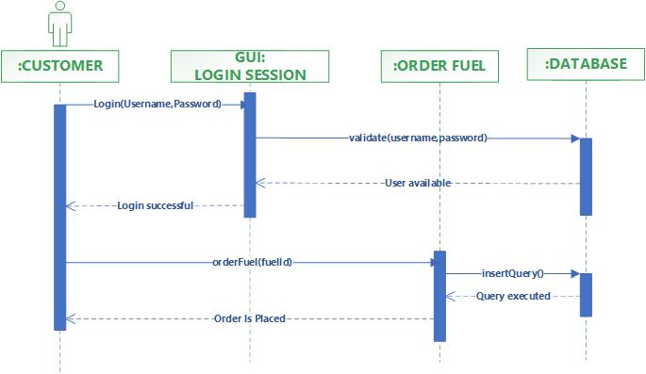Order Fuel:-

Search Gas Station:-

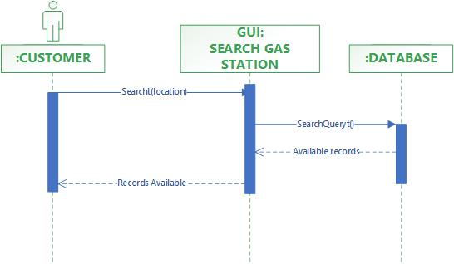

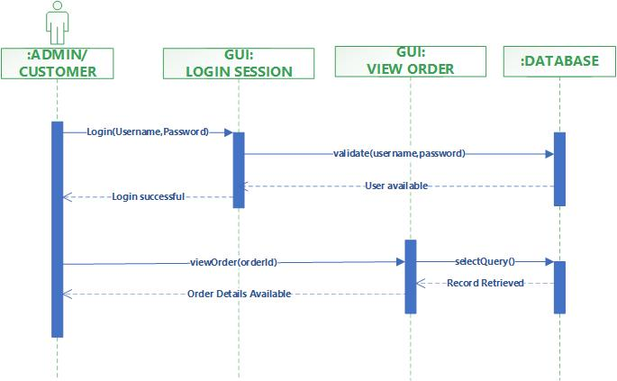View Order:-

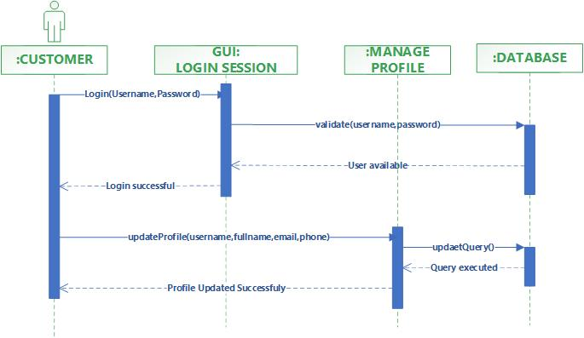Manage Profile:-

LOGOUT:-

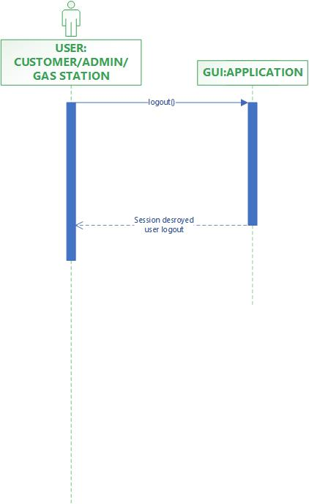

1. 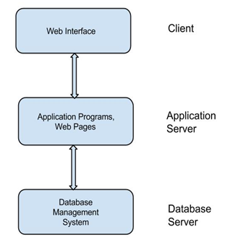Architecture Design Diagram
2. Class Diagram

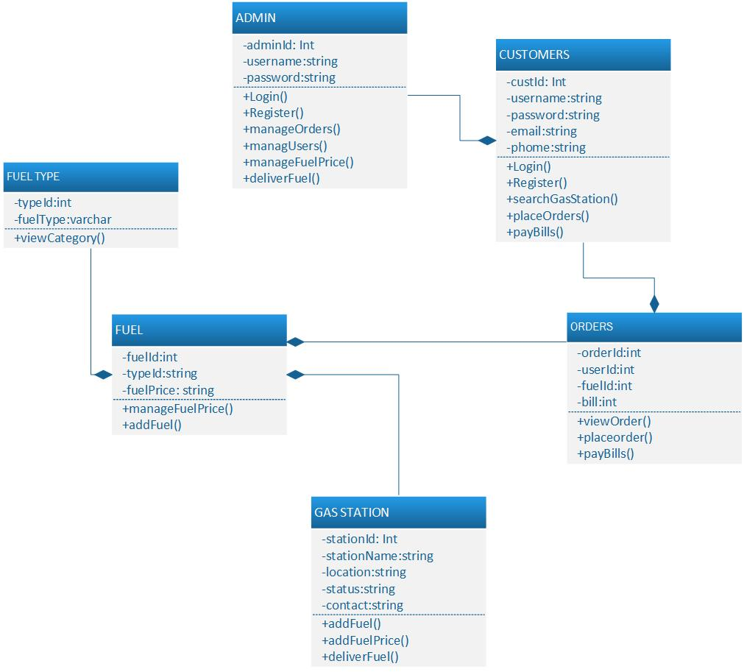

1. Database Design

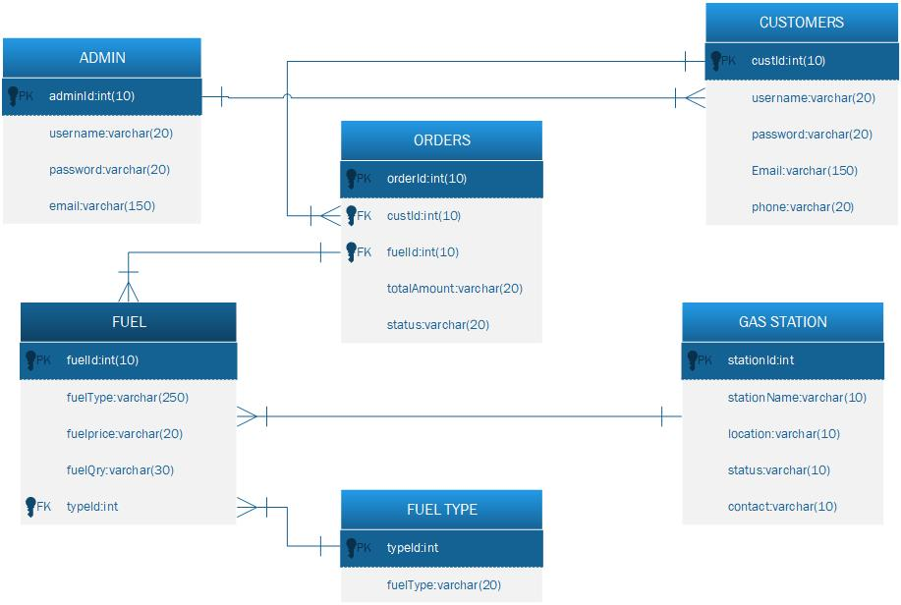

1. Interface Design

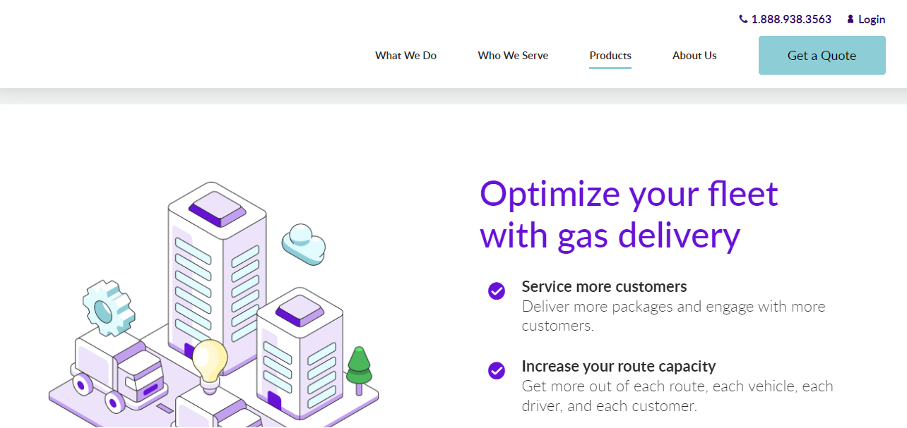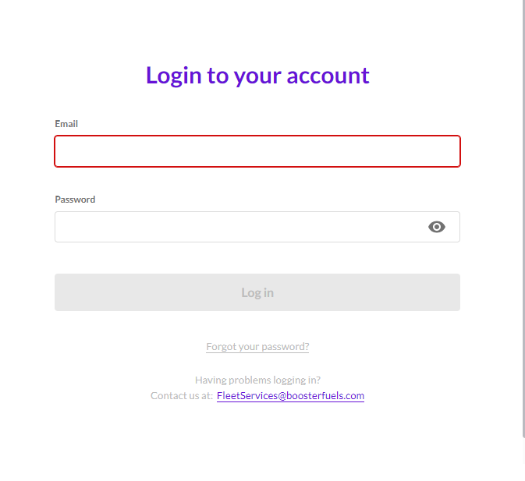

1. Test Cases

**REGISTER:**

|  |  |
| --- | --- |
| Pre-condition | Application interface must be available. |
| Action | 1. Open application interface of create account 2. Fill the form of registration 3. Click on “Register” button to get registered |
| Expected Results | Customers/Gas Station successfully created in database. |
| Results | Pass |
| Tested By | BC190402933 (Sughra Bibi) |

**LOGIN:**

|  |  |
| --- | --- |
| Pre-condition | Actors must be registered with our website , Application interface must be available |
| Action | 1. Open application interface of login 2. Enter user name and password 3. Click on “Login” button |
| Expected Results | Actors successfully login and able to further work |
| Results | Pass |
| Tested By | BC190402933 (Sughra Bibi) |

**MANAGE PROFILE:**

|  |  |
| --- | --- |
| Pre-condition | Customer of the system must be registered with our website and logged in. |
| Action | 1. Login as Customers 2. Fill update profile form 3. Click on “Update Profile” button |
| Expected Results | Profile successfully updated and |
| Results | Pass |
| Tested By | BC190402933 (Sughra Bibi) |

**ORDER FUEL:**

|  |  |
| --- | --- |
| Pre-condition | Application interface must be available. And system must be logged in as customer |
| Action | 1. Open application interface and select gas station 2. Add quantity of fuel 3. Add your delivery adress 4. Submit order fuel form |
| Expected Results | Order is placed and sent to that gas station |
| Results | Pass |
| Tested By | BC190402933 (Sughra Bibi) |

**TRACK ORDER:**

|  |  |
| --- | --- |
| Pre-condition | Application interface must be available. And system must be logged in as customer |
| Action | 1. Open application interface and view orders.php page 2. Status of your placed order will be available |
| Expected Results | Status details of your placed order will be available to customer |
| Results | Pass |
| Tested By | BC190402933 (Sughra Bibi) |

**VIEW ORDER HISTORY:**

|  |  |
| --- | --- |
| Pre-condition | Application interface must be available. And system must be logged in as Gas Station |
| Action | 1. Open application interface of gas station provider page 2. Select view all orders details 3. Details of all orders placed by customers will be available |
| Expected Results | Status details of your placed order will be available to customer |
| Results | Pass |
| Tested By | BC190402933 (Sughra Bibi) |

**MANAGE GAS STATION PROVIDER:**

|  |  |
| --- | --- |
| Pre-condition | Application interface must be available. And system must be logged in as Admin |
| Action | 1. Open application interface of create account 2. View manage_provider.php page 3. Select Particular provider to manage 4. Perform your desired actions i.e eidt/delete |
| Expected Results | Upated information added in database. |
| Results | Admin |
| Tested By | BC190402933 (Sughra Bibi) |

**MANAGE ORDERS:**

|  |  |
| --- | --- |
| Pre-condition | Application interface must be available. And system must be logged in as Skilled Worker |
| Action | 1. Open application interface of create account 2. View manage_services.php page 3. Select Particular Service to manage 4. Perform your desired actions |
| Expected Results | Upated information added in database. |
| Results | Pass |
| Tested By | BC190402933 (Sughra Bibi) |

**ADJUST FUEL PRICES:**

|  |  |
| --- | --- |
| Pre-condition | Application interface must be available. And system must be logged in as Admin |
| Action | 1. Open application interface of admin panel and login 2. View manage_services.php page 3. Select Particular Service to manage 4. Perform your desired actions |
| Expected Results | Upated information added in database. |
| Results | Pass |
| Tested By | BC190402933 (Sughra Bibi) |

**LOGOUT**

|  |  |
| --- | --- |
| Pre-condition | The application interface must be available and any of the actor must be Logged in. |
| Action | 1. Open application interface. 2. Click on Logout Button. |
| Expected Results | Session is destroyed and actor will be logout from system. |
| Results | Pass |
| Tested By | BC190402933 (Sughra Bibi) |